**Web development technologies**

**Coursework part 1**

**Federico Vivaldo**

**S1828951**

With the current worldwide pandemic, it is known that the majority of people are trying to change their job or apply their skills for different purposes, as on the internet all the useful information are disorganised and hard to find, a great idea would be to build a website from scratch that will provide beneficial information for everyone, formatted with a properly layout clearly understandable from everyone.

The type of data that will be found on the implemented website will be:

* Advice on jobs
* Available courses within different universities
* Funding info

**User group:**

The site is oriented for professionals who are currently looking for a different job, (maybe even from a totally different area of studies undertaking a different course frequenting a university), also for professional who are willing to retrain themselves trying to upgrade their abilities making their person more valuable. Those people will need to have access to specific type of data so that can be confronted and related to their current job, the website will need to be the more precise as possible.

It is expected that a part of the users will not be properly trained in using new modern technologies, in order to meet their needs the entire website will be easy to access and clear to understand with consistent layout and proper tools to guide through the experience.

Website will still be usable for people that just finished school but is not the main target focus.

|  |  |  |
| --- | --- | --- |
| **Main users:** | **Age:** | **Needs:** |
| Professionals | 25-50 | This user will need a fully functional, responsive website, they already have experience with technologies, they need something that can go straight to the point, fast and ensuring a pleasant overall experience |
| Professionals | 50+ | This range of user may not be experienced in using technology they will need a clear website, able to give them what they need helping them understanding every feature. The system will provide hints and clarifications on every input field. |
| Job seekers | Young and adults | This user is browsing the website to understand what they will do with their future carer. Every detail along the website will need to be well presented and clearly understandable. |
| School leavers | High school and above | This particular user is not the main target, but will still be able to use the website to obtain some details, they could navigate to the job section to understand what a specific job require or on the university page to search for a new instruction path. This user will need a clear and understandable interface. |

**Technologies:**

Different technologies and API will be used mainly to find relevant data for jobs and universities.

A call from (<http://api.lmiforall.org.uk/>) this API will be able to provide a soc code that will be later used to search for an occupation and all its relevant details, all this data will be passed through the website as the form of a JSON array and will then printed on screen with a proper layout and style.

<https://github.com/Hipo/university-domains-list> this API will then be used to provide universities data from all over the UK, a JSON array will then be manipulated to print on screen all the names of the universities with an embedded link to their relative website, some filter options will also be implemented to make the experience more easy to access.

3 main external links will be added for people who would like to search for any type of funding options, those will be clearly visible at the top of the universities page.

<https://www.thescholarshiphub.org.uk/>

<https://www.gov.uk/browse/education/student-finance>

<https://www.turn2us.org.uk/>

it is expected the minimum functionality of the system to work in this way:

* User type a job and the system will run a query to find an associated soc code

(if more than one soc code is associated for a category “title”, the user will be asked to specify it)

The soc code will then be used to print on screen info on that required job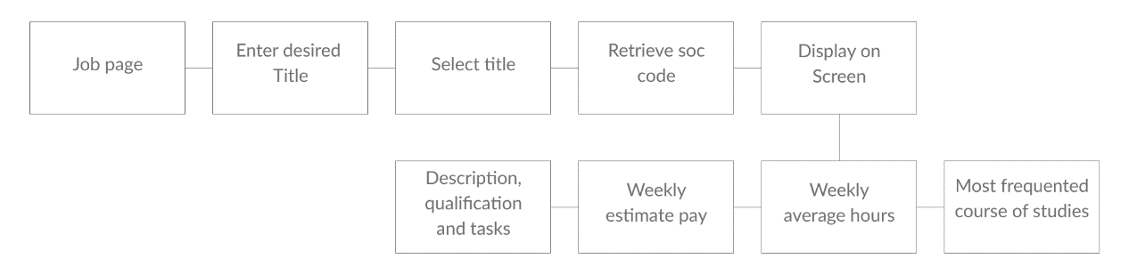

The system will process, and format provided data in different way, all the material regarding the description, qualification and tasks will be printed on screen as a block of text probably within a div tags. To display necessary data to build the graphs and charts the system will need to automatically detect the soc code and use it to perform other ajax query, the ashe API function will provide relevant data for The estimate pay chart and the average hour graph.

([**/ashe/estimateHours**](http://api.lmiforall.org.uk/#!/ashe/query))

([**/ashe/estimatePay**](http://api.lmiforall.org.uk/#!/ashe/query_0))

Hesa function will provide the data to build the pie chart showing the courses that people need to frequent to obtain a job for the requested title.

**(**[**/hesa/courses/{soc}**](http://api.lmiforall.org.uk/#!/hesa/getHESACourses)**)**

* If the user will choose to search for a university instead, on another page of the site a query from the university API will provide a list for all the campus available within the UK in a properly formatted layout, all the names will be placed between an anchor tag

to make them links for their relative website. 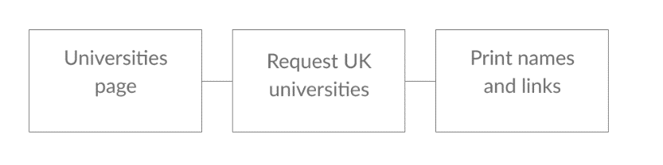

To simplify the user experience, a search box will come convenient to all the people who already know which university they want to search, the website will then provide a button to click that will guide the user to the chosen university website

Due to the massive length of the provided list the website will show only the first 10 universities available, user will be able to view more results by simply clicking a show more results button.

On the same page some useful links for funding options and general information will be provided

* On the about us page the user will find information about the website and a contact us form that will be used to store any message and send it to a MYSQL database using php.

**Site Structure:**

The website structure has been decided to be simple and elegant, it may vary over the implementation phase.

All the Html pages will be linked to each other to grant the user the most fluent experience possible, user will be able to navigate all the pages within a single click

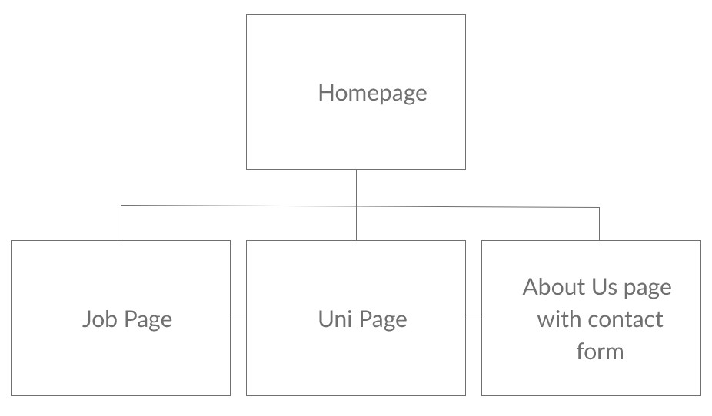

**File structure:**

The file structure may vary during the implementation phase, it is believed that all the file will be dived in folders by extensions this practise will keep the entire workflow clear and easy to access.

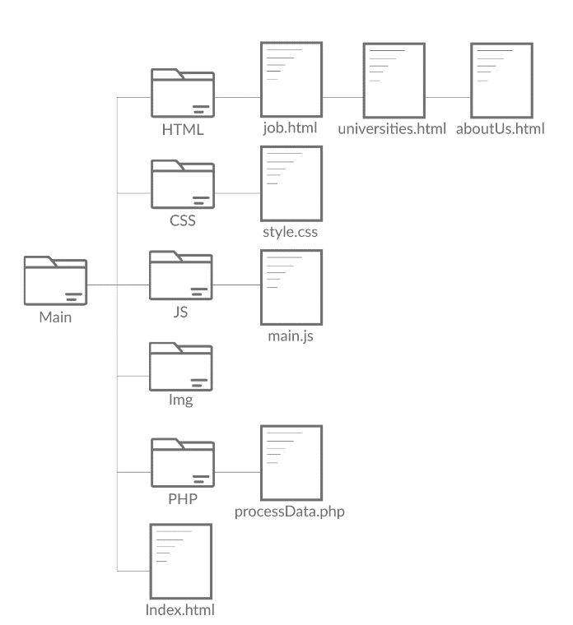

**Wireframes:**

three different wireframe sizes have been produced to fit the majority of the available devices currently in use. The website is designed to be as simple as possible with every interaction available whitin 1 to 3 clicks, users will never feel annoyed or frustrated using our website, all the input boxes will be prefilled with some prompt example text to help them.

A large interface for screens bigger than 1080px: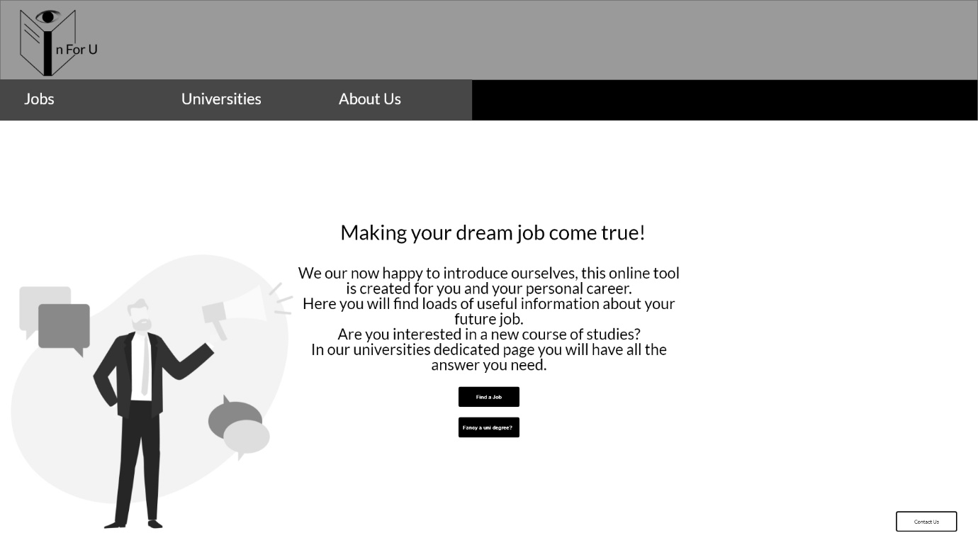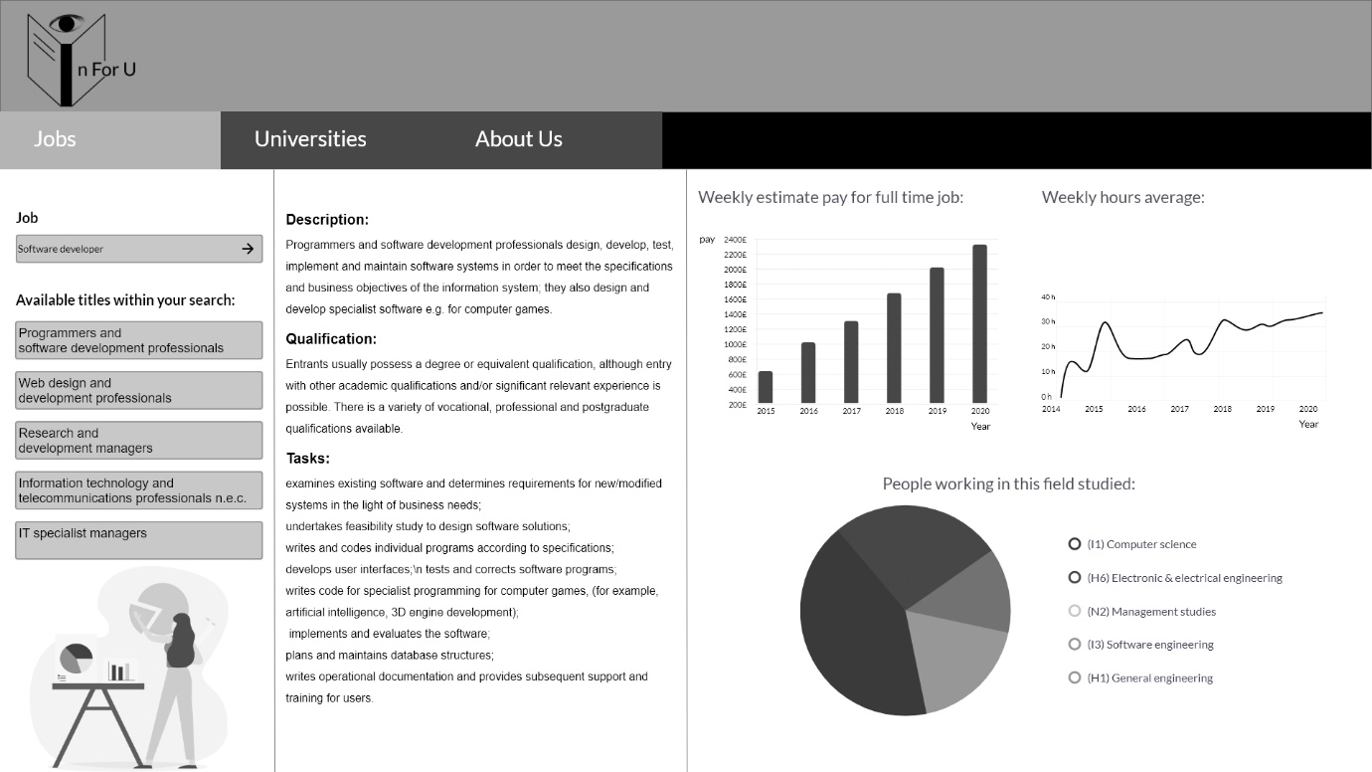

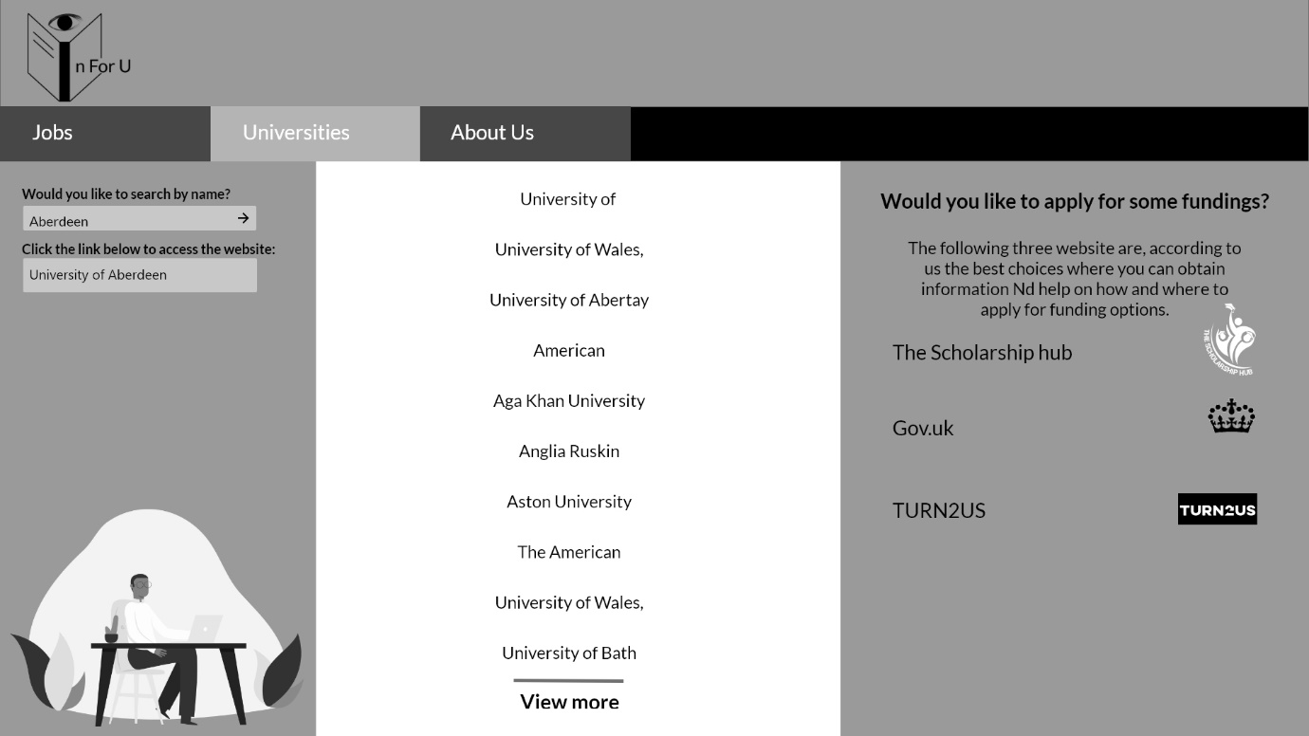

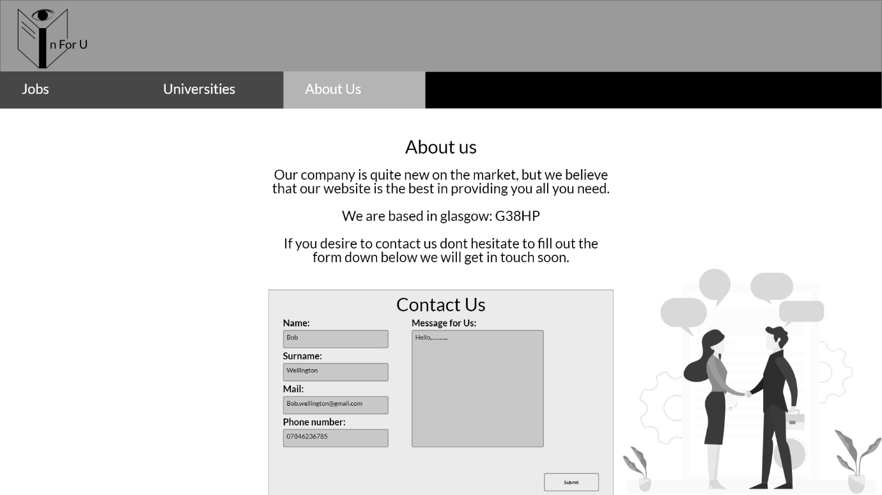

A medium interface for tablet, screen size 768px:



When the hamburger menu is pressed, the navigation menu is revealed.

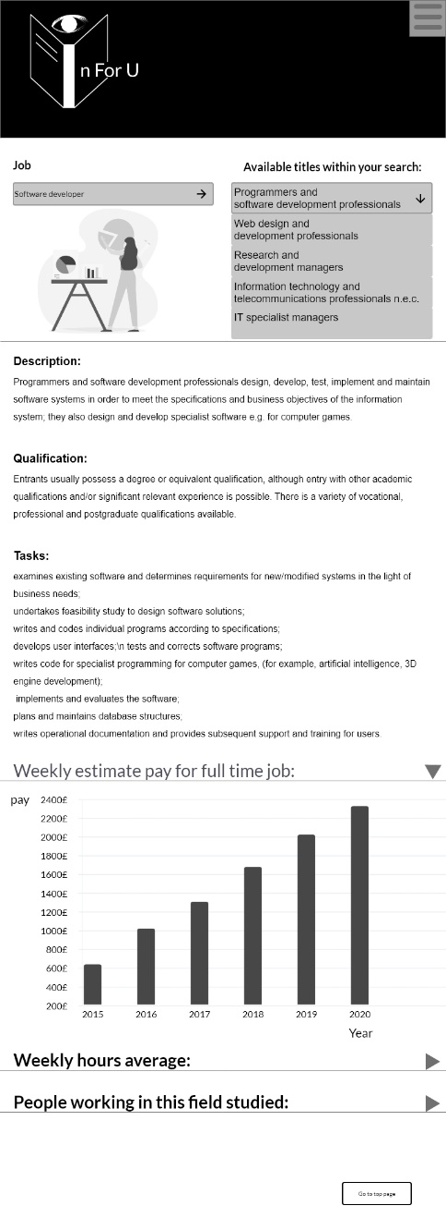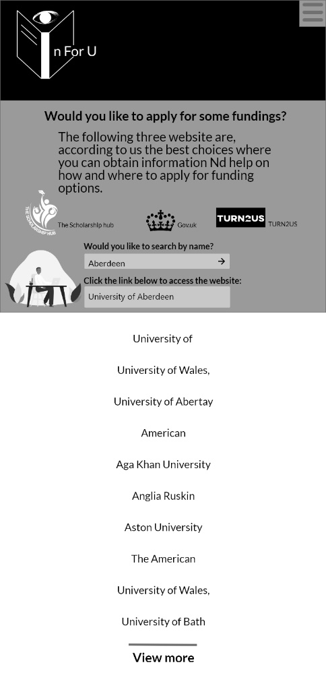

When these arrows are pressed the chart is revealed

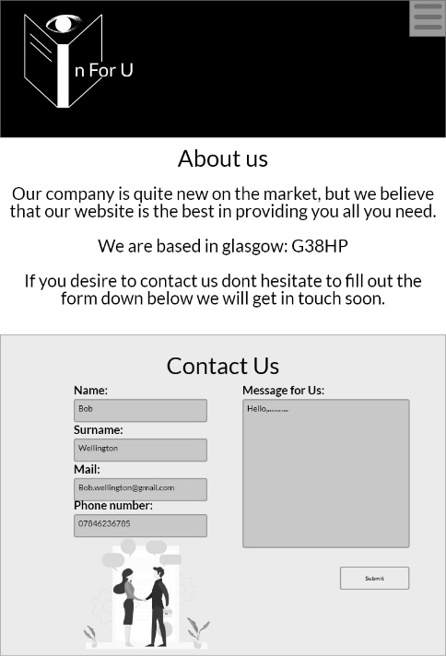

And a small interface mainly used on smartphone screens 360px and similar: 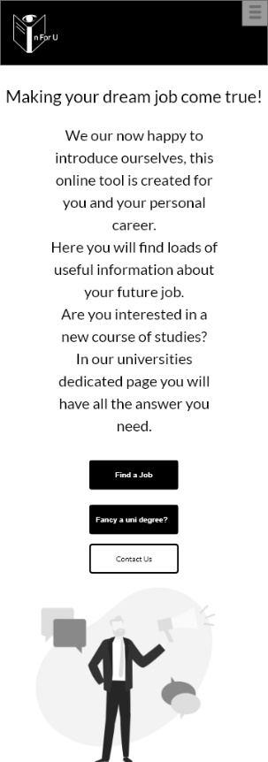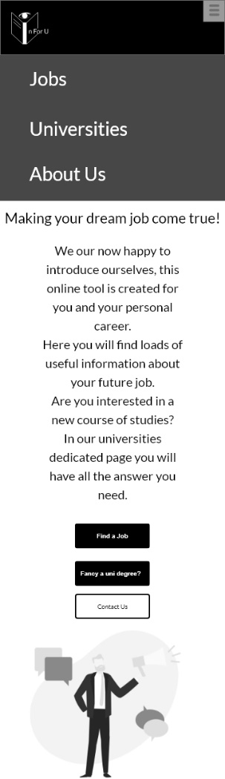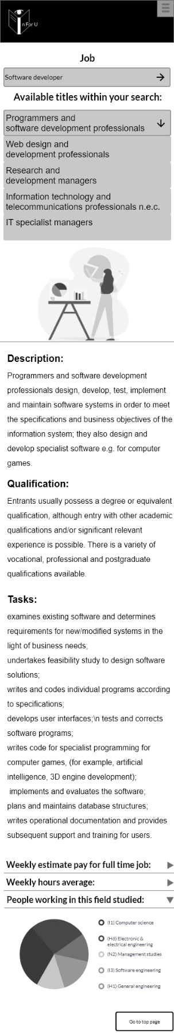

When the hamburger menu is pressed, the navigation menu is revealed.

When these arrows are pressed the chart is revealed

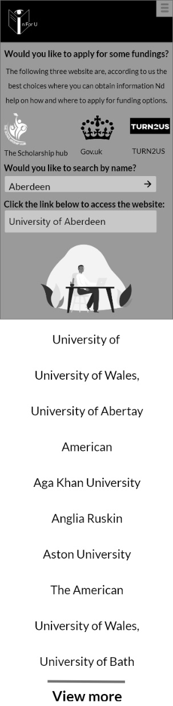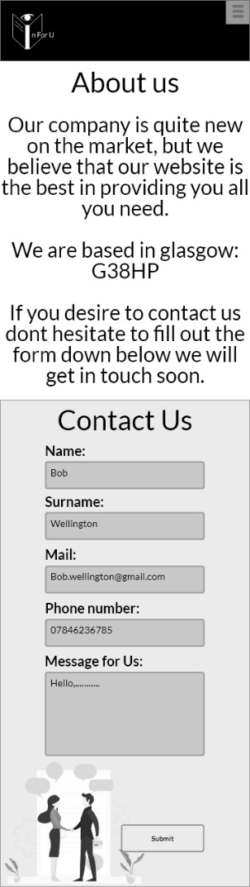

**Font:**

The proposed font is lato regular, being one of the most used in web design this font is clear and perfectly readable at every size. A large amount of people has eyesight problems. The decision of a standard font is the best for the service that the website is providing. Below some font example:

AaBbCcDdEeFfGg

**AaBbCcDdEeFfGg**

*AaBbCcDdEeFfGg*

**Visual samples:**

For the visual sample, some fundamentals and best practices of the colour theory will be applied, The website will tend to have a predominant shade of green which is a colour that inspire trust and stability to the user, this is so important, indeed our potential users are trusting us in providing the best details about their future job and career. Different highlights of yellow-amber shades are used to communicate enthusiasm in what we are doing and what the user will undertake.

Different shades of both the colours are used to make the website appealing and elegant.

Additional carefulness is to give the user the ability to understand where he is in the website and where he is going, this will be achieved adding hover animation and different colours for the active page, in this way a potential user will never feel lost.

Hover effects will also be added to any link or interactive piece of website.

Following the colours code used and the sample screen visual for the proposed solution.

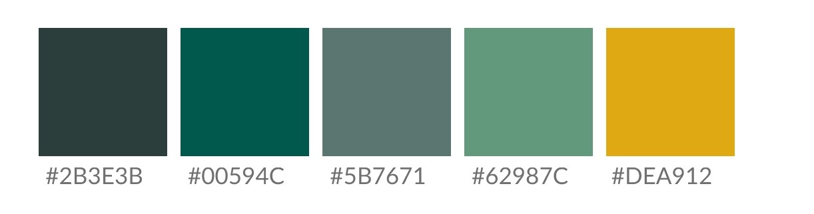

Visual sample for large screens:

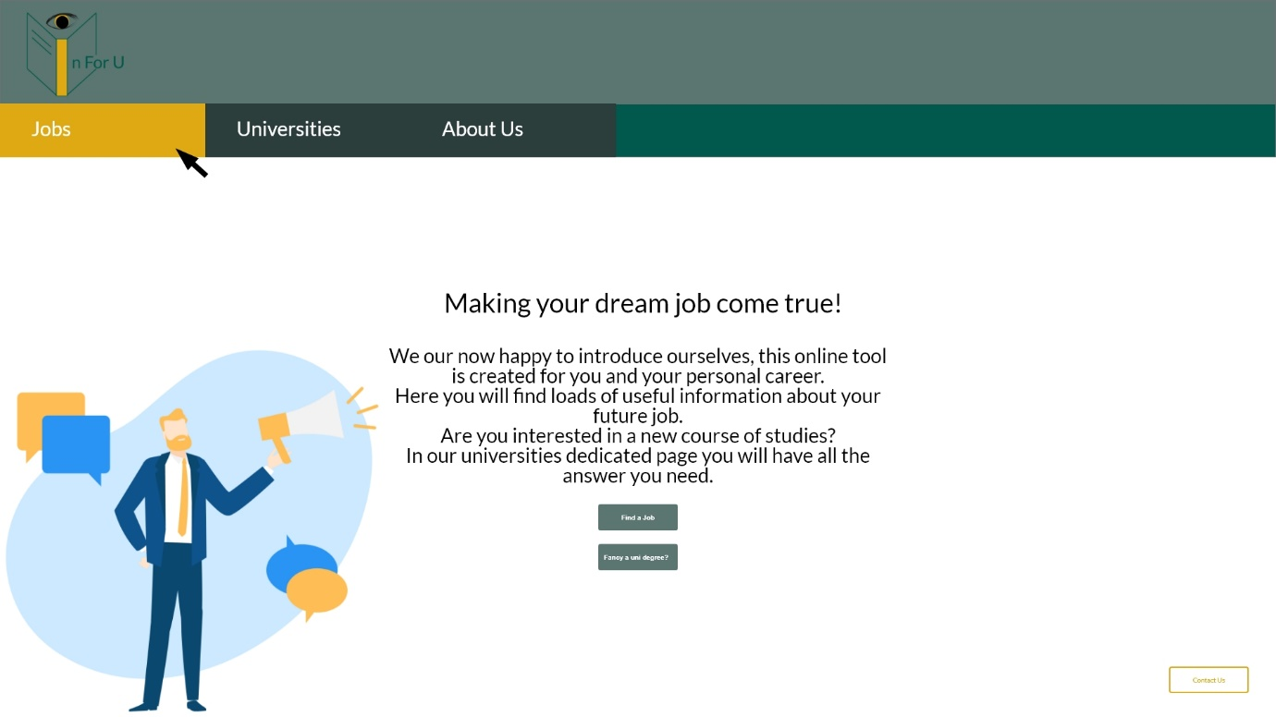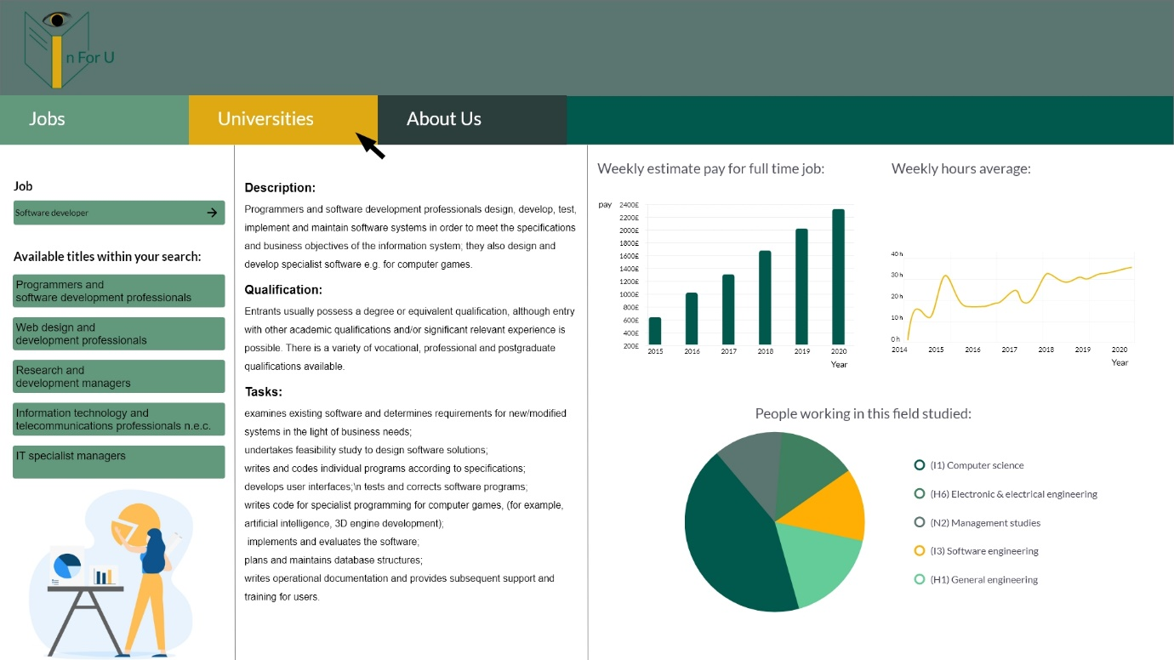

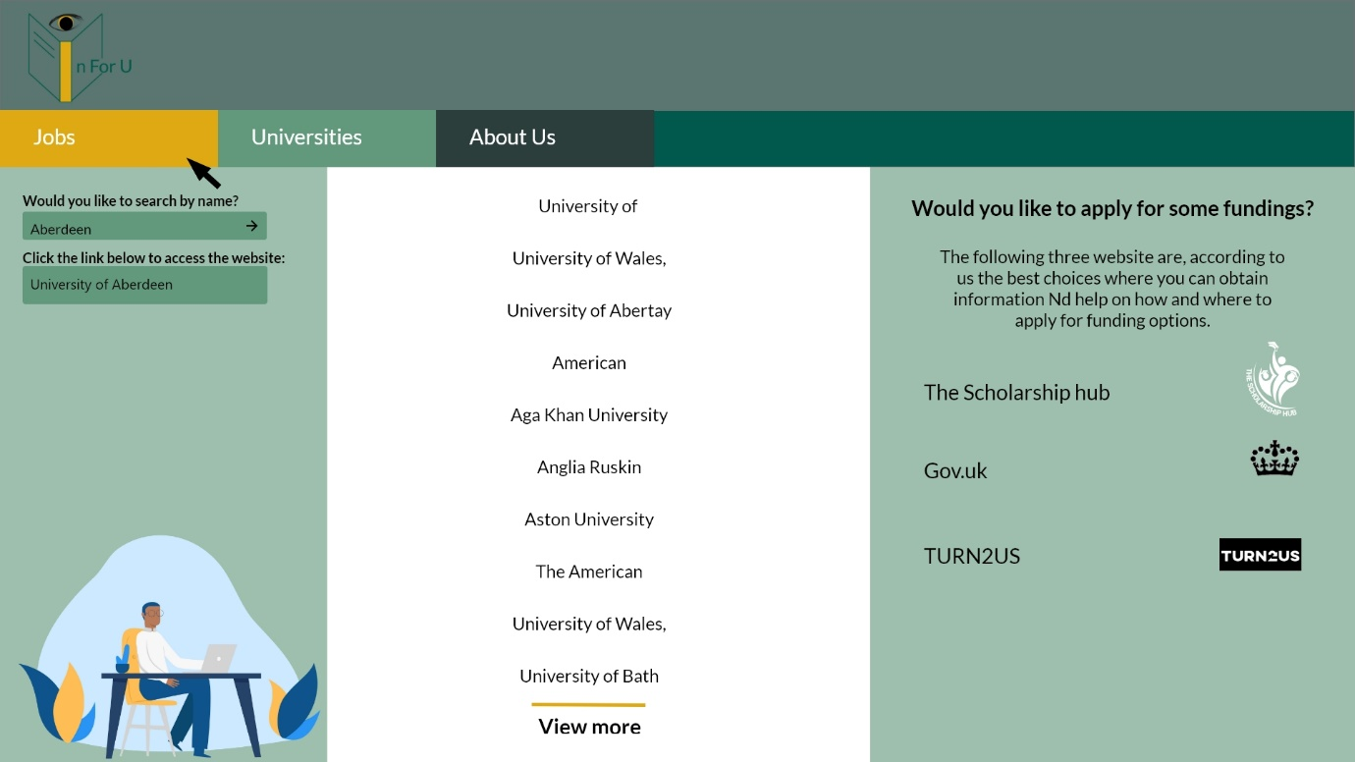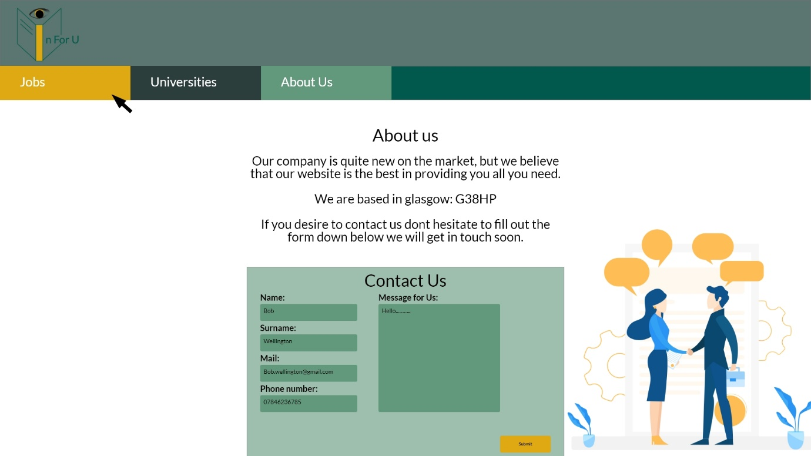

Visual sample for medium size screens:

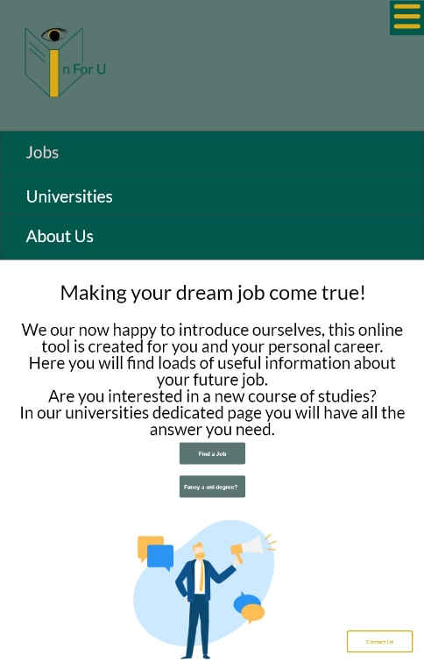

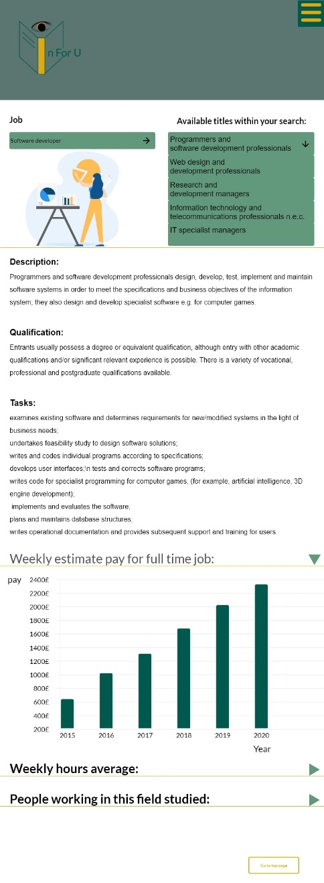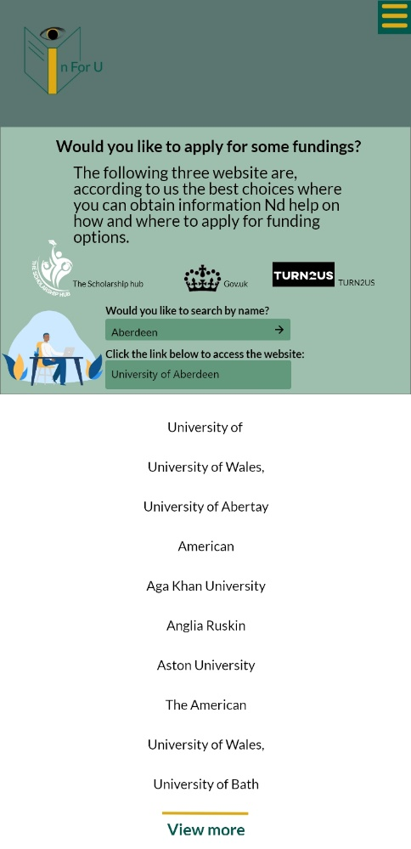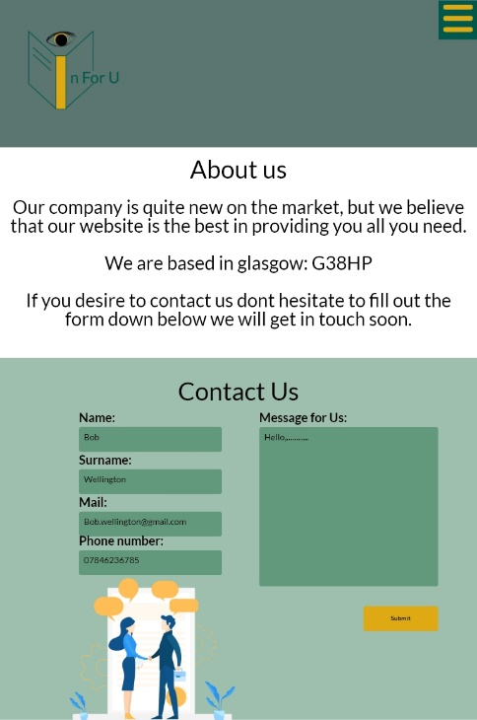

Visual sample for smaller screens:

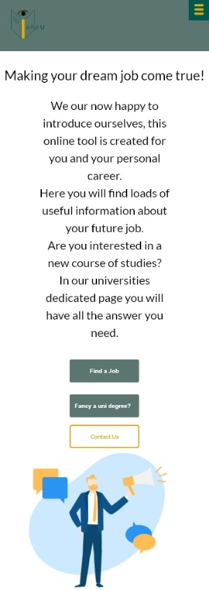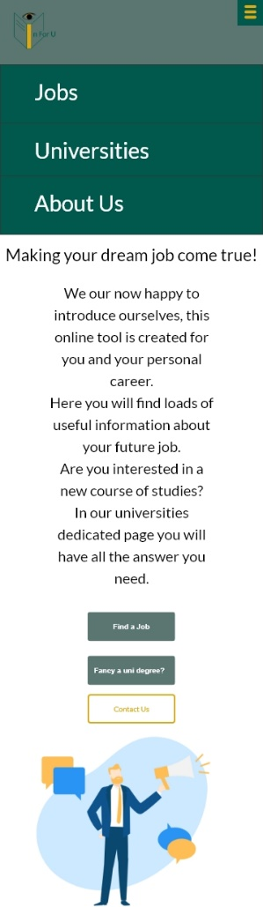

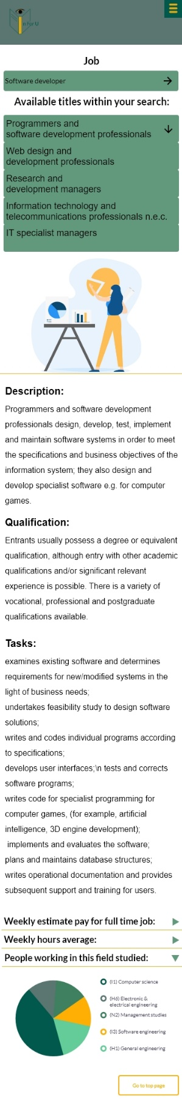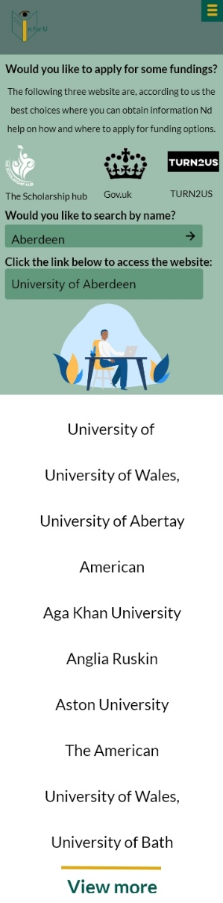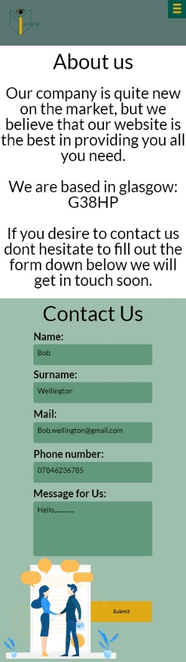

**References:**

url:https://thenextweb.com/dd/2015/04/07/how-to-create-the-right-emotions-with-color-in-web-design/

Cao, J., 2020. *Web Design Color Theory: How To Create The Right Emotions With Color In Web Design*. [online] The Next Web. Available at: <https://thenextweb.com/dd/2015/04/07/how-to-create-the-right-emotions-with-color-in-web-design/> [Accessed 21 November 2020].

All the website images were taken from:

<https://iconscout.com/illustration-pack/business-360>

Iconscout. 2020. *Download Free Business Illustration Pack From Business Illustrations*. [online] Available at: <https://iconscout.com/illustration-pack/business-360> [Accessed 21 November 2020].

Logo designed by the artist Anita Roscini.